* Component represent a part of the user interface.
* Component can contain other component.
* Component Type :
  + Stateless functional component
  + Stateful class component

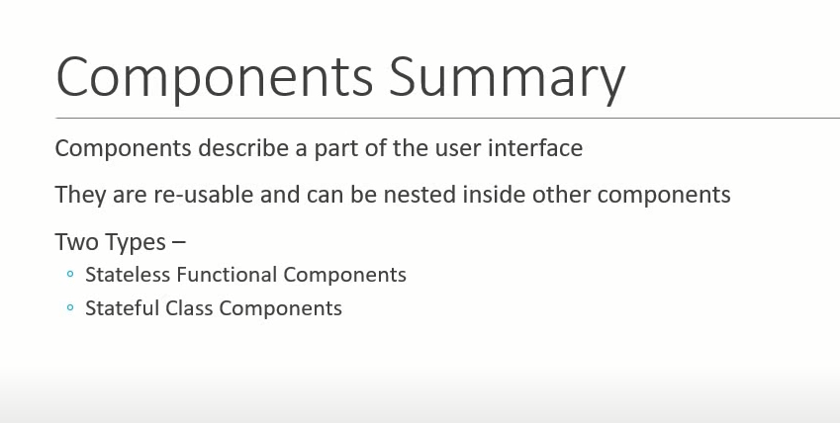

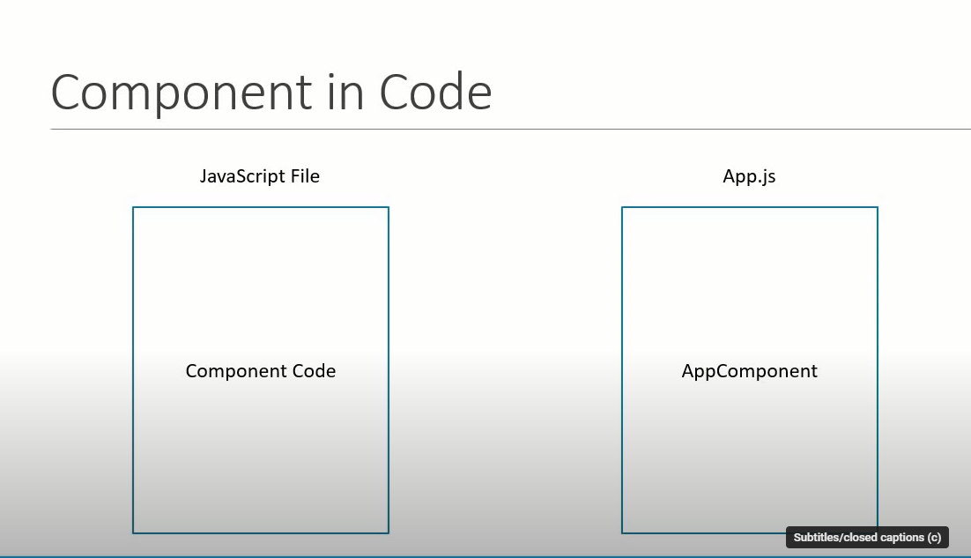

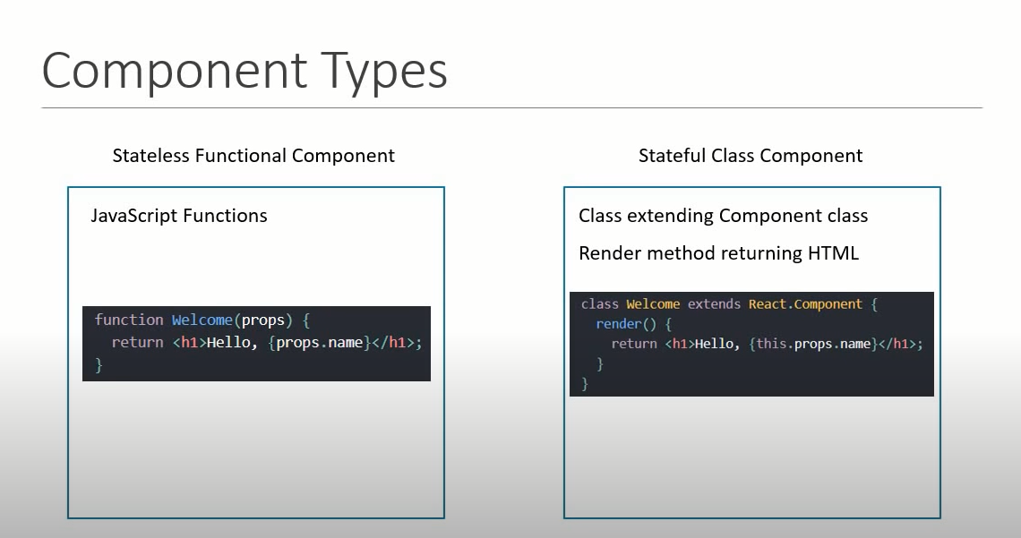

Functional components :

* Functional component is a javascript function that accepts an input(optional) of properties and return Html that describe the ui.

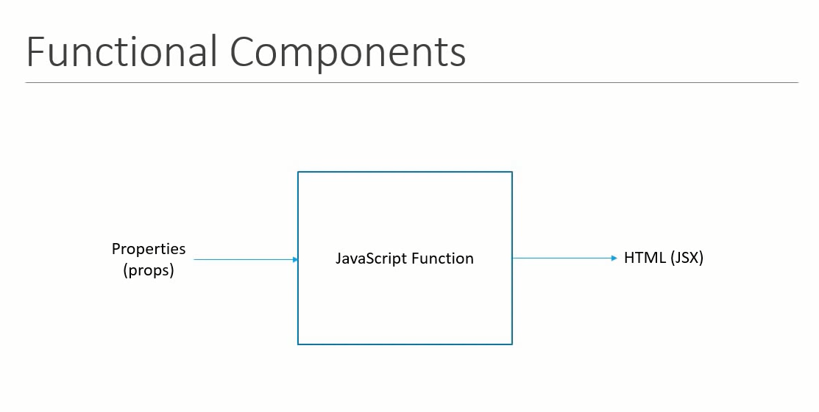

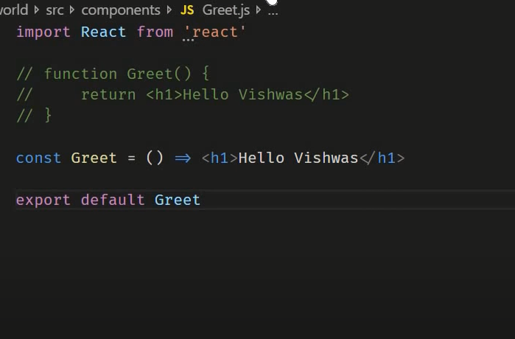

Class Component :

* Class component is that accepts an input(optional) of properties and return Html that describe the ui and also maintain some private or internal state(information).
* For class component import two packahge “ React and component”.

import React, {Component} from "react";

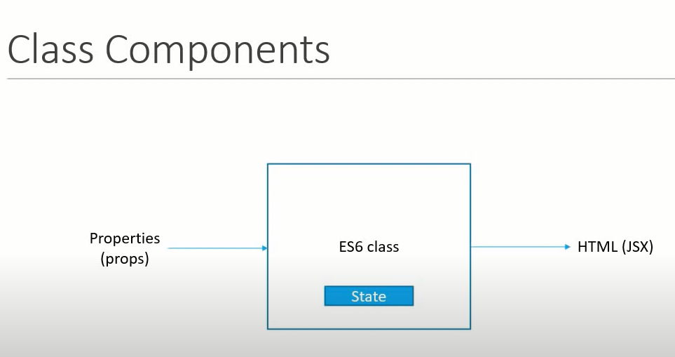

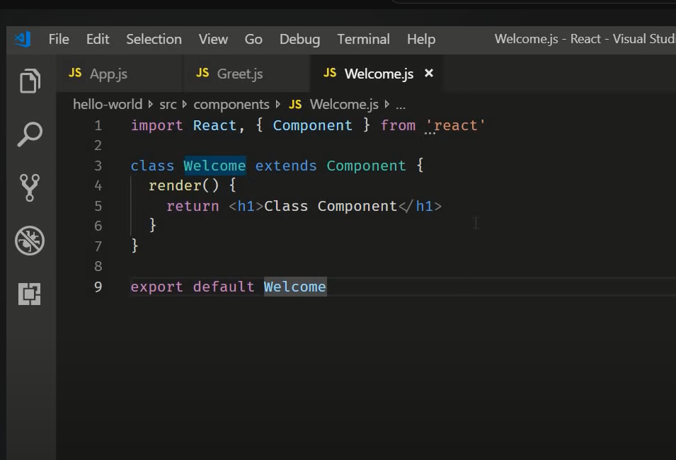

There is changes because of now functional component is not stateless

